Unit 1 / Reading Test
/60
Time: 1 hour
Name:

INSTRUCTIONS TO CANDIDATES
Read the instructions for each part of the paper carefully.
Answer all the questions.

READING
Questions 1–30 carry one mark.

SCORE:

PART 1 4

Hi there
There are several good hotels in Paris that aren’t too expensive. I’ll send you links. But probably the best option is to rent a small apartment.
Javier

Questions 1–6
For each question, choose the correct answer (A, B or C).

1
LIFE SKILLS TO TEACH YOUR CHILDREN
4-WEEK ONLINE COURSE (2 EVENINGS A WEEK)
For more details, email sascha@skilucation.org

A It is a full-time course on the internet.
B The course is for people of all ages.
C You need to write to get more information.

2

Hi Malek
I think I left my bag in your car yesterday. Can you check?
It’s got my sunglasses and ID card in it. Thanks!
Samir

What question does this message answer?
A Can you recommend somewhere cheap to stay in Paris?
B Where are you going to stay when you are in Paris?
C What is the best website for finding places to stay in Paris?

5

SAXOPHONE FOR SALE
A few scratches but in perfect working condition.
£80 or best offer.

A Malek took Samir’s bag instead of his own bag.
B Samir has lost his bag and is trying to find it.
C Samir wants Malek to look in his bag for some important possessions.

3
WANTED
Weekend shop assistant in busy clothing store.
Sales experience an advantage.
Contact Naomi C: naomi.c23@nc23.com

What is true about this job?
A You need to be able to work on Saturdays and Sundays.
B You must know how to make things.
C You need to understand the fashion industry.

A You can buy the saxophone or exchange it for another instrument.
B The seller will accept less than £80 for the saxophone.
C The saxophone is second-hand but looks and plays like new.

6

Jana
I’d like to wear my yellow dress to Katja’s party. But if you want to wear yours, no problem. I can
choose something else.
Lena

A Lena can’t decide what clothes she wants to wear to the party.
B Lena is not sure if she will go to Katja’s party with Jana.
C Lena wants to make sure she and Jana don’t wear the same colour.

PART 2

Questions 7–13
For each question, choose the correct answer.

YOUR MOST INTERESTING HOLIDAY

Dion
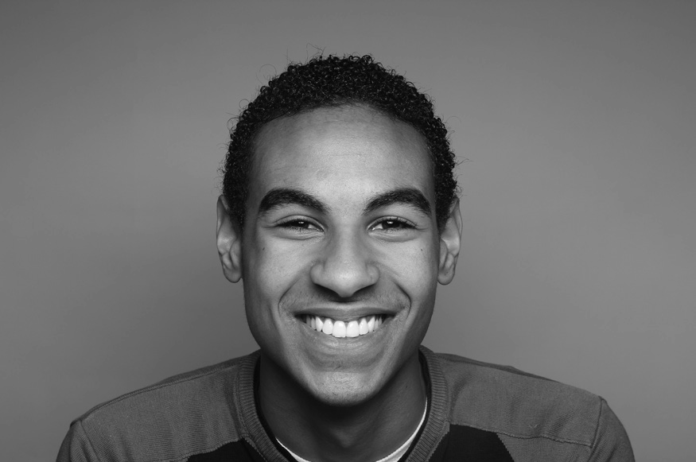
When I was twelve my mum and I went on a cycling trip. It felt really special because usually my whole family travel together. We didn’t have a schedule. If we wanted to stop and look at something, we stopped.
If we found a beautiful place by a lake or river, we camped there. Some days we cycled 60 kilometres; other days only 10. It was a true adventure, but without stress or worry.

Marco

When I left college, I went on a road trip around Europe with three of my best friends. We spent months planning it. I think we visited 14 different cities in 30 days. We also went to a music festival in Croatia, which was amazing. Probably we tried to do too much, because we all felt really tired at the end, especially Jack, who did the driving. But we’d love to do it again one day!

FEI

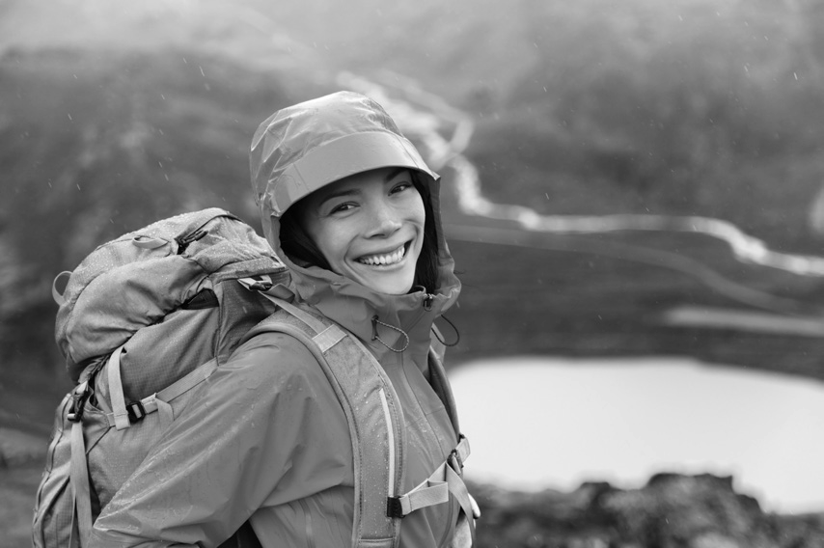
I’ve never liked the idea of travelling by myself, but that’s what happened to me last year. I was on a hiking holiday in Nepal with a friend and she got ill one night and had to come home. I decided to stay on. It was interesting because I had more time to talk to other people and more time to notice new things. It was definitely a richer experience because of that. But I still felt sorry for my friend!
 | Dion | Marco | Fei
7 Who went on holiday in a car? | A | B | C
8 Who spent the night close to nature? | A | B | C
9 Who wants to repeat their holiday experience? | A | B | C
10 Who had a holiday that was different from the | A | B | C
original plan?
11 Who says they normally went on holiday in a larger group? | A | B | C
12 Who didn’t have a very relaxing holiday? | A | B | C
13 Who had to make an important decision on | A | B | C
their holiday?

PART 3

Questions 14–18
For each question, choose the correct answer.


The art of making friends
Having friends is very important for our health. Scientists say that people who don’t have friends often die younger. In fact, they say it is the same danger to your health as smoking fifteen cigarettes a day. So how can we make friends? Here are five useful tips.
- Smile and be open. If you seem closed or angry, no- one will come and talk to you. People will think you are having a bad day and leave you alone.
- Do activities that you enjoy. When you do things you enjoy – playing sport, going to concerts, joining an art or cooking class – you meet people who have the same interests. That makes it easier to start a conversation because you have something in common.
- Don’t wait for other people to make the first move. If you see someone sitting or standing alone, go up to them and say hello. What’s the worst that can happen?
- Make a plan to meet again. Say something nice about meeting the person, for example, ‘It was great to chat to you. Let’s do it again some time.’ Then take the person’s contact details so that you can arrange to meet.
- Say yes to invitations. Sometimes, when people invite us to do things, we don’t accept. Not because we’re too busy, but because we don’t think it will be fun. But when we go, we actually have a really good time.
14 What does the writer say about people who don’t have friends?
A They are not healthy.
B They live shorter lives.
C They usually smoke.
15 It is important to do activities you enjoy because then you will ...
A meet people you can easily talk to.
B feel more relaxed.
C have more interesting conversations.
16 The writer thinks we shouldn’t ...
A talk to someone before they talk to us.
B walk up to people when they are not alone.
C worry about greeting people we don’t know.
17 It’s important to tell the other person ...
A that you enjoyed meeting them.
B if you have a phone or not.
C where you want to meet next time.
18 Sometimes we don’t accept invitations because we’re ...
A not interested.
B too tired.
C too busy.

PART 4

Questions 19–24
For each question, choose the correct answer.


People power
The number of people living in our cities is growing day by day. These people (19) ……… a lot of energy. Cities are also noisy and dirty places. So, city planners have to
(20) ……… a problem. How can they produce energy that is quiet and (21) ………?
The company Pavegen has had a clever idea. They build roads and walkways that can make energy. So as people walk (22) ………, their feet push down on a part of the road that catches the energy. This energy then becomes electricity. The best places for this new technology,
says Pavegen, are (23) ……… places, like busy streets or shopping centres or (24) ……… at railway stations. It has already sold its products in over 36 countries.

19 A spend | B use | C take
20 A solve | B tidy | C repair
21 A clear | B close | C clean
22 A off | B on | C along
23 A crowded | B empty | C modern
24 A ceilings | B platforms | C stages

PART 5

Questions 25–30
For each question, write the correct answer. Write one word for each gap.
Example: 0 …on… Dear Sir / Madam,
I am writing about the job advertised (0) ..................
your website. I would really like (25) work
as a helper in a children’s camp this summer.
I am in the middle of a 3-year university course in sports science. My main sports are tennis and basketball, but I
(26) play lots of other sports too.
I (27) worked with children before.
(28) summer I was an assistant sports
teacher at a local school. We worked with children aged between 12 and 16.
I really (29) being outside and trying to
make activities fun for children.
I attach a CV which has details of (30) .................. skills and experience. I can start work any time after 2nd June.
I look forward to hearing from you. Yours faithfully,
Danny W

