Bryan García Valenzuela
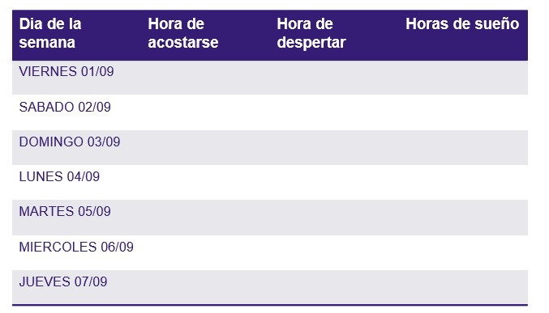
8 horas
8 horas
8 horas
8 horas
11 horas y media
13 horas
7 horas y media
1:00 pm
6:30 am
6:30 am
6:30 am
6:30 am
11:00 am
6:30 am
10:30 pm
12:00 pm
11:00 pm
10:30 pm
10:30 pm
10:30 pm
10:30 pm

