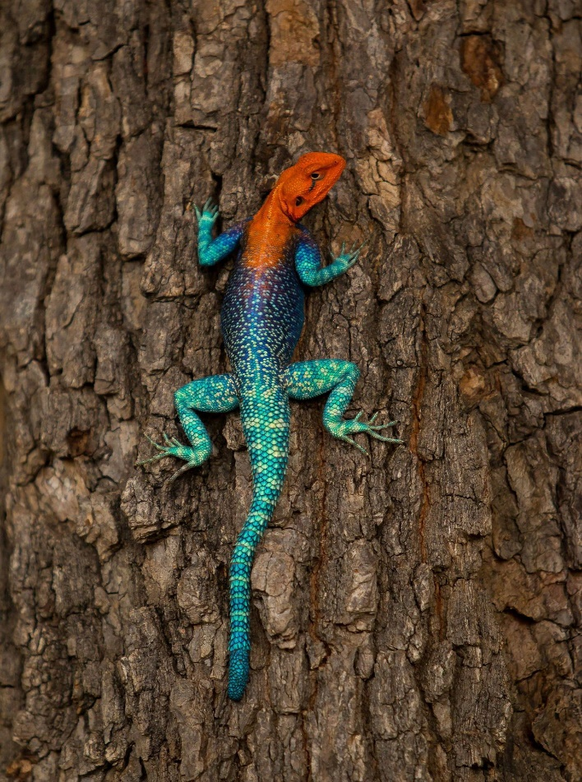
I like this image since it is a very curious animal with colors, white, red, blue and purple

