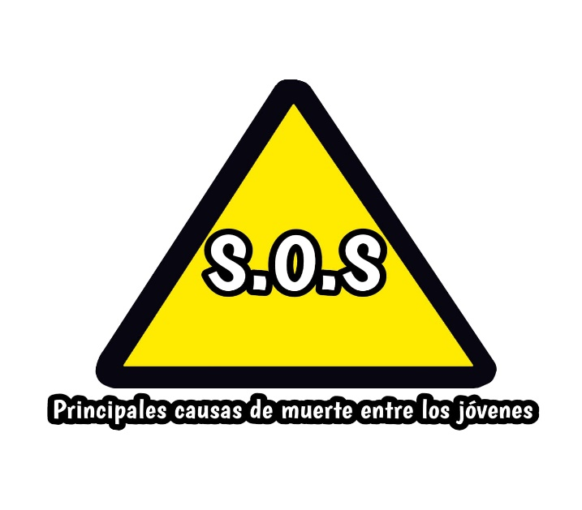
YOUNG ENTREPRENEURS FORUM

S.O.S: Main causes of death among young people

Knowledge area: Scientific Disclosure
Name of the participants: Evelyn “Alex” Guadalupe Leal Félix

Title: S.O.S: Main causes of death among young people
Short summary
This project consists of making a comic about some of the most common causes of death that young people face today, such as mental health, bullying, and road accidents. It is aimed mainly at young people our age (16 years) and even adults. It was carried out by making a comic that dealt with the aforementioned topics, sending it to young people our age and then doing a simple survey.
Background
Until the first half of the 20th century, mental health care was centered in psychiatric hospitals, whose purpose was mainly to keep people hospitalized because they were considered dangerous to themselves or to third parties.
This model alienated affected people from the rest of society, generating isolation, discrimination, stigmatization, and poor recovery from the disease. This way of organizing mental health services is called the asylum model. This model was strongly criticized, not only because of the poor evidence of improvement it showed, but also because they were a constant space for the violation of the Human Rights of the people who were there.
It is very probable that right from those dates, at the beginning of the school stage in our country, bullying manifested itself within the premises where knowledge was received. It is very simple, the phenomenon was unknown and no authority, under the ways of thinking of those years, was interested in anything other than academic knowledge, which, why not say it, was taught rigorously by rote, that is, , it was about mechanically learning all the classes.
Conflicts between students were repressed with calls for attention or ignored because they were considered children's games.
In fact, in our country, it existed, or does it exist? The belief that it was healthy to let the children “harden up a bit” so that they were getting to know “the reality of life” and so that they were learning to defend themselves. Even the teachers of those times used to punish acts of indiscipline by putting humiliating nicknames, applying physical punishment and exposing the accused students.

Problem Statement
On a global scale, mental and behavioral disorders are concrete indicators that demonstrate the importance of the mental health of individuals and of society, as well as the lack of health services oriented towards community primary care. The increasing deterioration of mental health on a global scale is not only due to individual factors, but also to psychosocial conditions and factors that make people vulnerable, such as: disasters due to earthquakes, climatic phenomena, wars, terrorist attacks, political and social instability. , economic and labor, high rates of poverty, accidents, kidnappings, etc.
Today the concepts of bullying and its implications are unknown. It is presented, on the one hand, that among students there is disrespect either verbally, psychologically or physically and they believe that these are jokes that later end up in acts of aggression or intimidation. On the other hand, teachers who show facts of possible aggression between students and ignore these behaviors, as the opposite usually happens, in normal youth games, some teachers interpret these as bullying. Likewise, due to ignorance of this subject, managers and teachers of official schools can commit this type of act by not realizing it.
Context
The problem is global, since the aforementioned causes of death exist in all countries, but this time we will focus on Mexico.
Individual mental health is determined by multiple social, psychological, and biological factors. For example, persistent socioeconomic pressures are a well-known risk to the mental health of individuals and communities. The most evident evidence is related to indicators of poverty, and in particular to the low level of education.
Many people believe that bullying or bullying has possibly always existed, at least since the 19th century, when children began to attend schools in a general way. On the other hand, it cannot be said with certainty that it is currently increasing: possibly what happens is that today there is greater social sensitivity regarding this problem, which is why victims (and their families) report cases more and put pressure for solutions, and the media spread news about this issue.
The solutions that have been implemented for these problems have been campaigns, informative videos, advertisements or commercials, short films, etc. These solutions have not worked because young people often see this type of thing and think that it will never happen to us, also because many times we do not think about the consequences that the decisions we make will bring or those who may affect other than ourselves. . Many times we don't think, we just do it.
Justification
The relevance of the problem of these three issues is that some of them are not talked about or are not treated as much as bullying is, and we believe that being informed about these issues is important so that the necessary preventions and measures can be taken to deal with them. these problems.
The contribution we seek to make to the scientific community is to inform and make people aware of how serious these problems can become if people don't treat them and don't get informed about them.
General objective
Make a comic or a cartoon where a situation is presented in which the themes that we selected for the project are implemented, which are: Road accidents, the main cause of death of young people, mental health and bullying.
Specific objectives
- Research on mental health, bullying and road accidents among young people.
-Make history
-Do the script
-Make the cartoon
Hypothesis
Our comic will help raise awareness about the most common causes of death among young people and we will touch sensitive topics giving it a slightly creative and "softer" approach to make it more digestible and entertaining to read.
Materials:
1. Sketchbook (special notebook for drawing)
2. Pencils
3. Eraser
4. Stylus
5. Watercolor paint
6. Internet

Conclusion
According to the results obtained, it can be concluded that the objective of the project has been successfully achieved.
We conclude that our comic was able to create awareness in the people who read it, it was a positive impact since the people who contacted us to tell us what they thought of the story, the majority said that it was very good and that it helped them to think a A little more about the risks that a problem we are dealing with may have, they also agreed that the ending, although it was realistic to the situation presented, was at the same time unfair.

